**EMBRYOLOGY**

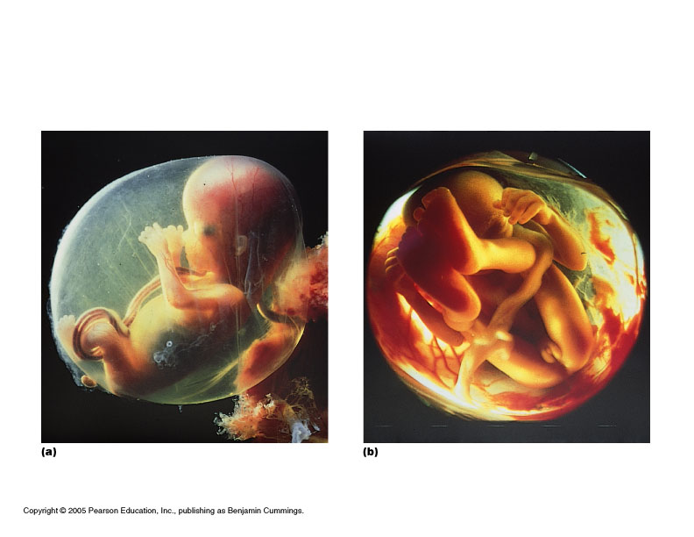

* Definition: the study of the origin and development of an organism
* Prenatal period: before birth
  + 38 weeks from conception to birth (average) “fetal” age

Traditional (artificial) division:

* “Embryonic” period: first 8 weeks
  + All major organs formed
  + “Fetal” period: remaining 30 weeks
  + Organs grow larger and become more complex
* 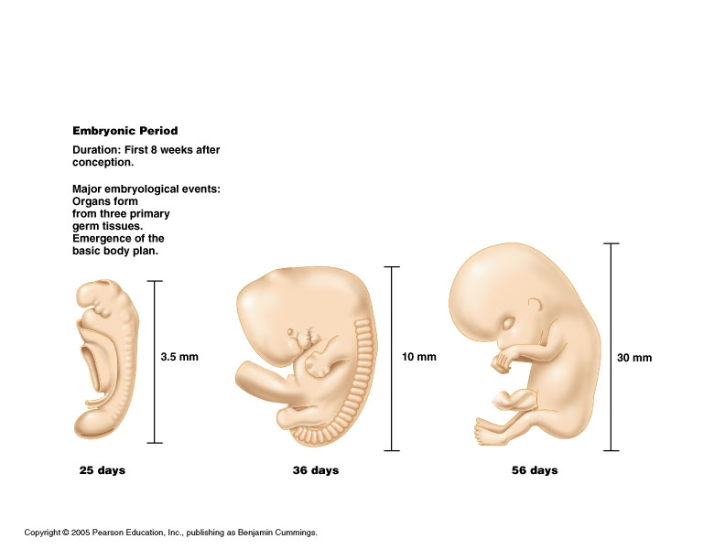

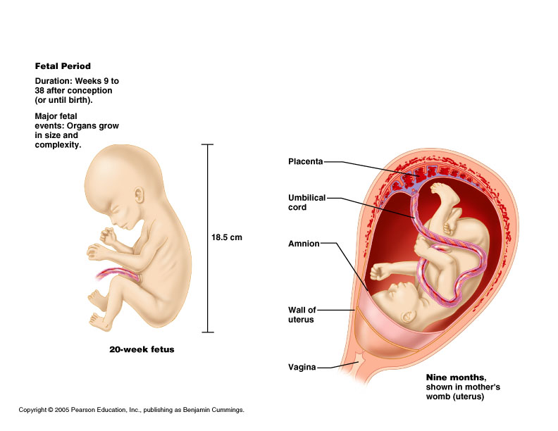

**Fertilization to Implantation**

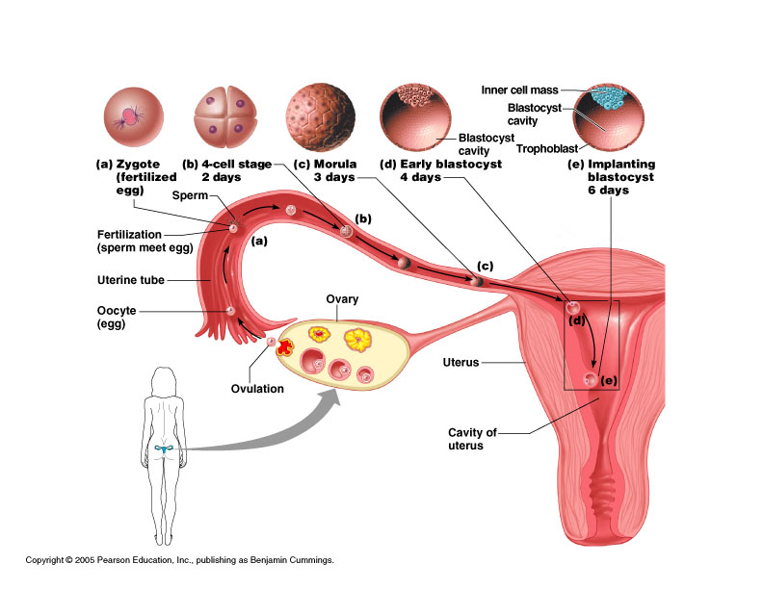

* Ovulation: egg released into the peritoneal cavity
* Travels down fallopian tube in which fertilization occurs
* At conception in fallopian tube, maternal and paternal genetic material join to form a new human life (zygote)
* Cell division occurs with travel down the tube and into the uterus

**Week 1 post conception**

* ***Zygote*** divides repeatedly moving down tube toward uterus (cleavage)
* The daughter cells are called ***blastomeres***
* ***Morula***: the solid cluster of 12-16 blastomeres at about 72 hours
* Day 4: late 60 cell morula enters uterus, taking up fluid becoming ***blastocyst***

**Blastocyst stage**

* Two distinct types of cells
  + ***Inner cell mass***: forms the embryo
  + ***Trophoblast***: layer of cells surrounding the cavity which helps form the placenta
* Floats for about 3 days
* ***Implantation*** on about day 6 post conception
  + Trophoblast erodes uterine wall
  + Takes 1 week to complete
* If inner cell mass of a single blastocyst divides: monozygotic (identical) twins

**HCG**

* HCG is **human chorionic gonadotropin**
* It is produced by the trophoblasts starting on day 6
* hCG is a hormone
* hCG causes endometrium of uterus to grow and proliferate
* hCG prevents the menstrual cycle from occurring
* This is why a female misses her periods when she is pregnant

Week 2

* Inner cell mass divides into epiblast and hypoblast
* 2 fluid filled sacs
  + ***Amniotic sac*** from epiblast
  + Yolk sac from hypoblast
* Bilaminar ***embryonic disc***: area of contact(gives rise to the whole body)

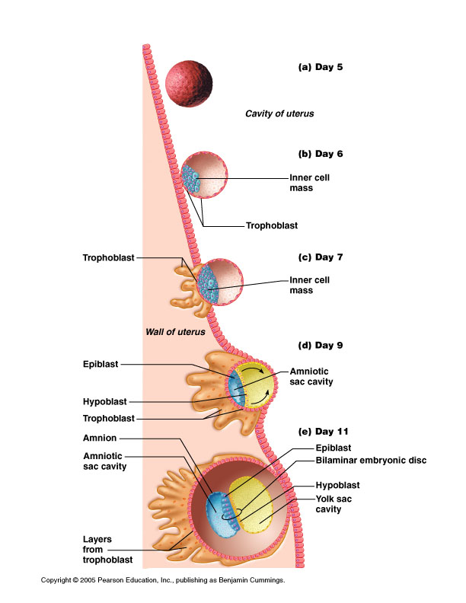

* Three primary “germ” layers: all body tissues develop from these
  + - Ectoderm
    - Endoderm
    - Mesoderm

Formation of the 3 “germ” layers

* Primitive streak (groove) on dorsal surface of epiblast
* Grastrulation: invagination of epiblast cells
* Days 14-15: they replace hypoblast becoming ***endoderm***
* Day 16:  ***mesoderm*** (a new third layer) formed in between
* Epiblast cells remaining on surface: ***ectoderm***
* “Germ” as in germinate, not germs
* Early specialization of cells
* Are precursors
* Ectoderm and endoderm are epithelial tissue (form sheets of tissue)
* Mesoderm is a mesenchyme tissue
  + Mesenchyme cells are star shaped and do not attach to one another, therefore migrate freely

Notochord

* Days 16-18
* Primitive node epiblast cells invaginate and migrate anteriorly with some endoderm cells
* Rod defining the body axis is formed
* Future site of the vertebral column

Neurulation

* Notochord signals overlying ectoderm
* There begins Formation of spinal cord and brain (neurulation)
* Neural plate to neural groove to neural tube: pinched off into body
* Closure of neural tube: begins at end of week 3; complete by end of week 4 (folic acid important for this step)
* Extends cranially (eventually brain) and caudally (spinal cord)
* Neural crest, lateral ectodermal cells, pulled along and form sensory nerve cells and other structures
* Mesoderm begins to differentiate
  + Lateral to notochord, week 3
  + Extends cranially and caudally (from head to tail or crown to rump)
* Division of mesoderm into three regions
  + Somites: 40 pairs of body segments (repeating units, like building blocks) by end week 4
  + Intermediate mesoderm: just lateral to somites
  + Lateral plate: splits to form coelom (“cavity”)

Divisions of the mesodermal lateral plate

* Somatic mesoderm: apposed to the ectoderm
* Splanchnic mesoderm: apposed to the endoderm
* Coelom in between will become the serous cavities of the ventral body cavity:
  + Peritoneal
  + Pericardial
  + Pleural

**Major derivatives of the embryonic germ layers**

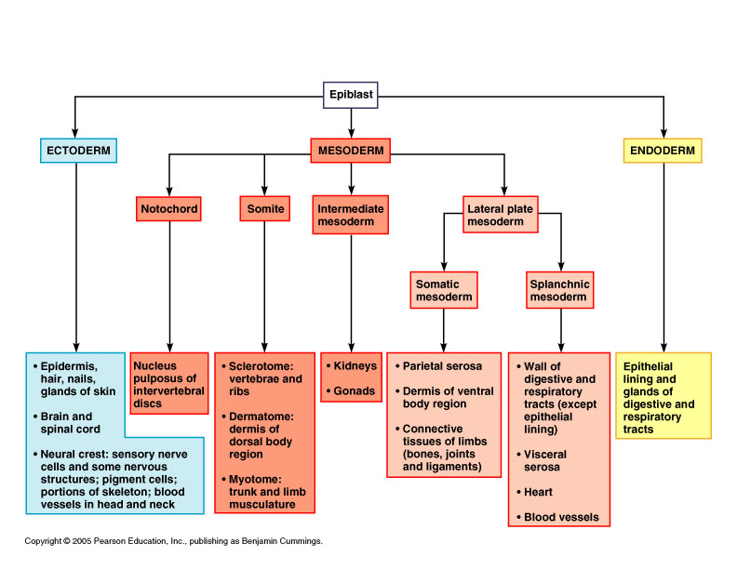

**29 day embryo  
(this is when the heart starts pumping, about 4 weeks or 1 month, ½ cm size)**

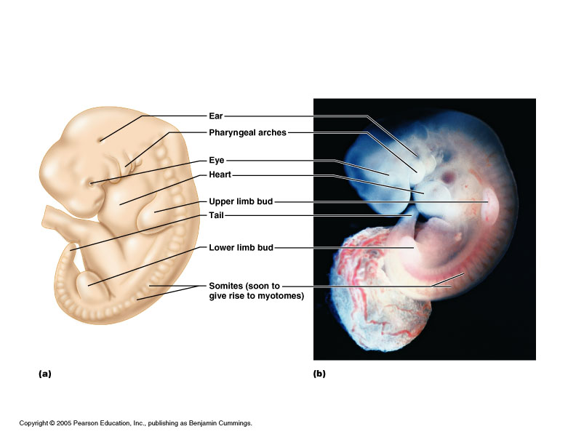

**3 month fetus** **(6 cm)**  **late 5th month(about 19 cm)**







**Questions**

* Define the terms *anatomy* and *physiology*, and explain their relationship using an example of a human structure with its corresponding function.
* List, in order from least to most complex, the levels of structural organization, discuss the relationship between the levels, and name an example at each level.
* Define the term *homeostasis*, and name the manner in which homeostatic mechanisms are regulated. Then provide an example of a homeostatic mechanism in humans, and explain it fully, by providing a diagram followed by a complete essay explanation.
* Demonstrate what is meant by "anatomical position".
* Define various directional terms (i.e. superior, inferior, etc.), and compare different body parts using these terms (i.e. the elbow is proximal to the wrist).
* List both anterior and posterior anatomical landmarks (i.e. orbital, inguinal, etc.).
* Name the three major body sections (planes, cuts), and describe how each would be accomplished.
* Designate the five major human body cavities and name the organs within each on a human diagram.
* Describe the anatomical importance of the *diaphragm* muscle.
* Describe the nine regions of the abdominal area and the four quadrants of the abdominal area and list the major organs found within each.
* Distinguish between visceral and parietal serous membranes, and differentiate between pericardial, pleural, and peritoneal varieties.

**TISSUES**

I. Types of Tissues

A. Cells——tissues——organs——organ systems——organism

B. Tissue: Composed of specialized cells of the same type that perform a common function in the body.

* Epithelial tissue: Covers body surfaces and lines body cavities.
* Connective tissue: Binds and supports body parts. Muscular tissue: Moves the body and its parts.
* Nervous tissue: Receives stimuli and conducts nerve impulses.
* Cancers are classified according to the type of tissue from which they arise.
* Sarcomas: Cancers arising in muscle or connective tissue.